Cuban Primes
# Source: AI Source: Provided by: [Data Path: Persons Table -> ID Column: 1, Name_En Column: Motasem Essam] -> From: [ChatGPT] on [7/13/2026]
A Cuban prime is a prime number that is also a Cuban number. There are two types of Cuban numbers, but unless otherwise specified, the term Cuban prime usually refers to a Cuban prime of the first kind, which has the form
$$C_{n}=\frac{\left(n+1)^{3}-n^{3}\right.}{ }=3n^{2}+3n+1,$$
where
- $n$is a positive integer, and
- $C_{n}$is itself prime.
Cuban primes are studied in number theory because they arise from the difference of two consecutive cubes.

Definition
# Source: AI Source: Provided by: [Data Path: Persons Table -> ID Column: 1, Name_En Column: Motasem Essam] -> From: [ChatGPT] on [7/13/2026]
A Cuban prime (first kind) is a prime number of the form
$$C_{n}=(n+1)^{3}-n^{3},$$
which simplifies to
$$C_{n}=3n^{2}+3n+1,$$
where
- $n$is a positive integer.
- $C_{n}$is prime.

Rules for Cuban Primes

1. The Number Must Be the Difference of Two Consecutive Cubes
# Source: AI Source: Provided by: [Data Path: Persons Table -> ID Column: 1, Name_En Column: Motasem Essam] -> From: [ChatGPT] on [7/13/2026]
Every Cuban prime must be expressible as
$$\left(n+1)^{3}-n^{3}.\right.$$
Since
$$(n+1)^{3}-n^{3}=3n^{2}+3n+1,$$
both formulas are equivalent.
Example
For
$$n=1, \\ 2^{3}-1^{3}=8-1=7.$$
Since
$$7$$
is prime,
it is a Cuban prime.

2. The Index Must Be a Positive Integer
# Source: AI Source: Provided by: [Data Path: Persons Table -> ID Column: 1, Name_En Column: Motasem Essam] -> From: [ChatGPT] on [7/13/2026]
The value
$$n$$
must be a positive integer.
Examples
Valid values:
$$1, 2, 3, 4, 5,…$$
Invalid values:
$$0, -2, 2.5.$$

3. Not Every Cuban Number Is Prime
# Source: AI Source: Provided by: [Data Path: Persons Table -> ID Column: 1, Name_En Column: Motasem Essam] -> From: [ChatGPT] on [7/13/2026]
Most Cuban numbers are composite.
Example
For
$$n=3, \\ 4^{3}-3^{3}=64-27=37.$$
Since
$$37$$
is prime,
this one is a Cuban prime.
However,
for
$$n=8, \\ 9^{3}-8^{3}=729-512=217.$$
Since
$$217=7×31,$$
217 is not a Cuban prime.

4. The Result Must Be Prime
# Source: AI Source: Provided by: [Data Path: Persons Table -> ID Column: 1, Name_En Column: Motasem Essam] -> From: [ChatGPT] on [7/13/2026]
The value
$$3n^{2}+3n+1$$
must itself be prime.
Example
For
$$n=5, \\ 3(5)^{2}+3(5)+1=75+15+1=91.$$
Since
$$91=7×13,$$
91 is not a Cuban prime.

5. Cuban Primes Grow Quadratically
# Source: AI Source: Provided by: [Data Path: Persons Table -> ID Column: 1, Name_En Column: Motasem Essam] -> From: [ChatGPT] on [7/13/2026]
Unlike Mersenne, Cullen, or Woodall primes, Cuban primes grow according to the quadratic polynomial
$$3n^{2}+3n+1.$$

6. Cuban Primes Become Less Frequent
# Source: AI Source: Provided by: [Data Path: Persons Table -> ID Column: 1, Name_En Column: Motasem Essam] -> From: [ChatGPT] on [7/13/2026]
As
$$n$$
increases,
Cuban primes become increasingly rare.

7. It Is Unknown Whether Infinitely Many Cuban Primes Exist
# Source: AI Source: Provided by: [Data Path: Persons Table -> ID Column: 1, Name_En Column: Motasem Essam] -> From: [ChatGPT] on [7/13/2026]
Mathematicians do not know whether infinitely many Cuban primes exist.
This remains an open problem.

First Cuban Primes
# Source: AI Source: Provided by: [Data Path: Persons Table -> ID Column: 1, Name_En Column: Motasem Essam] -> From: [ChatGPT] on [7/13/2026]
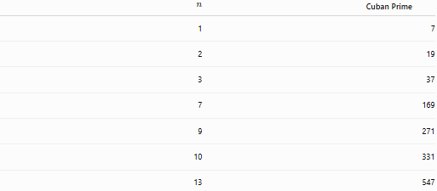
$$n$$ | Cuban Prime
1 | 7
2 | 19
3 | 37
7 | 169
9 | 271
10 | 331
13 | 547
Note: Although
$$169={13}^{2}$$
is not prime, it is not a Cuban prime. The actual sequence skips this value.
The first Cuban primes are therefore
$$7, 19, 37, 61, 127, 271, 331, 397, 547,…$$

Examples
# Source: AI Source: Provided by: [Data Path: Persons Table -> ID Column: 1, Name_En Column: Motasem Essam] -> From: [ChatGPT] on [7/13/2026]
Example 1
Determine whether
$$7$$
is a Cuban prime.
$$7=2^{3}-1^{3}.$$
Since
$$7$$
is prime,
it is a Cuban prime.

Example 2
Determine whether
$$19$$
is a Cuban prime.
$$19=3^{3}-2^{3}.$$
Since
$$19$$
is prime,
it is a Cuban prime.

Example 3
Determine whether
$$37$$
is a Cuban prime.
$$37=4^{3}-3^{3}.$$
Since
$$37$$
is prime,
it is a Cuban prime.

Example 4
Determine whether
$$91$$
is a Cuban prime.
$$91=6^{3}-5^{3}.$$
Since
$$91=7×13,$$
it is composite.
Therefore,
91 is not a Cuban prime.

Example 5
Determine whether
$$127$$
is a Cuban prime.
$$127=8^{3}-7^{3}.$$
Since
$$127$$
is prime,
it is a Cuban prime.

Example 6
Determine whether
$$217$$
is a Cuban prime.
$$217=9^{3}-8^{3}.$$
Since
$$217=7×31,$$
it is composite.
Therefore,
217 is not a Cuban prime.

Common Cuban Primes
# Source: AI Source: Provided by: [Data Path: Persons Table -> ID Column: 1, Name_En Column: Motasem Essam] -> From: [ChatGPT] on [7/13/2026]
Some well-known Cuban primes are
$$7, \\ 19, \\ 37, \\ 61, \\ 127, \\ 271, \\ 331, \\ 397, \\ 547.$$

How to Determine Whether a Number Is a Cuban Prime
# Source: AI Source: Provided by: [Data Path: Persons Table -> ID Column: 1, Name_En Column: Motasem Essam] -> From: [ChatGPT] on [7/13/2026]
- Express the number as
$$\left(n+1)^{3}-n^{3}\right.$$
or
$$3n^{2}+3n+1.$$
- Verify that
$$n$$
is a positive integer.
- Test whether the resulting number is prime.
- If all conditions are satisfied, it is a Cuban prime.
Example
Check
$$271. \\ 271={10}^{3}-9^{3}.$$
Since
$$271$$
is prime,
271 is a Cuban prime.

Real-Life Applications
# Source: AI Source: Provided by: [Data Path: Persons Table -> ID Column: 1, Name_En Column: Motasem Essam] -> From: [ChatGPT] on [7/13/2026]
Cuban primes are primarily used in:
- Number theory research
- Computational mathematics
- Prime number searches
- Primality testing
- Algorithm development
- Mathematical software
- Computer science
- Mathematics education
- Theoretical mathematics
- Research in polynomial-generated primes

Real-Life Examples
# Source: AI Source: Provided by: [Data Path: Persons Table -> ID Column: 1, Name_En Column: Motasem Essam] -> From: [ChatGPT] on [7/13/2026]
1. Number Theory Research
Researchers study Cuban primes to understand primes generated by polynomial formulas.

2. Computational Mathematics
Large Cuban numbers provide benchmark cases for primality-testing algorithms.

3. Prime Number Searches
Computer programs search for new Cuban primes using optimized primality tests.

4. Mathematical Software
Computer algebra systems generate Cuban numbers and determine which are prime.

5. Difference of Cubes
Cuban primes demonstrate how the difference between consecutive cubes can produce prime numbers.

6. Mathematics Education
They provide an elegant example of simplifying algebraic expressions while studying special prime families.

Common Mistakes
# Source: AI Source: Provided by: [Data Path: Persons Table -> ID Column: 1, Name_En Column: Motasem Essam] -> From: [ChatGPT] on [7/13/2026]
- Confusing Cuban numbers with Cuban primes.
- Forgetting that the resulting number must be prime.
- Assuming every difference of consecutive cubes is prime.
- Forgetting that
$$\left(n+1)^{3}-n^{3}=3n^{2}+3n+1.\right.$$
- Confusing Cuban primes with other polynomial-generated primes.

Key Points
# Source: AI Source: Provided by: [Data Path: Persons Table -> ID Column: 1, Name_En Column: Motasem Essam] -> From: [ChatGPT] on [7/13/2026]
- A Cuban prime (first kind) has the form
$$\left(n+1)^{3}-n^{3}.\right.$$
- An equivalent formula is
$$3n^{2}+3n+1.$$
- The index
$$n$$
must be a positive integer.
- The resulting number must be prime.
- Cuban primes arise from the difference of consecutive cubes.
- Whether infinitely many Cuban primes exist remains an open problem.

Cuban Primes vs. Carol Primes
# Source: AI Source: Provided by: [Data Path: Persons Table -> ID Column: 1, Name_En Column: Motasem Essam] -> From: [ChatGPT] on [7/13/2026]
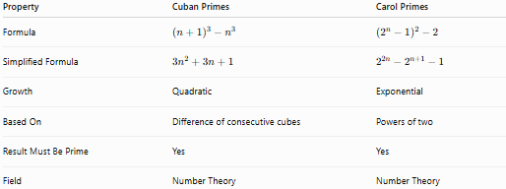
Property | Cuban Primes | Carol Primes
Formula | $$\left(n+1)^{3}-n^{3}\right.$$ | $$\left(2^{n} − 1)^{2} − 2\right.$$
Simplified Formula | $$3n^{2}+3n+1$$ | $$2^{2n}-2^{n+1}-1$$
Growth | Quadratic | Exponential
Based On | Difference of consecutive cubes | Powers of two
Result Must Be Prime | Yes | Yes
Field | Number Theory | Number Theory

Conclusion
# Source: AI Source: Provided by: [Data Path: Persons Table -> ID Column: 1, Name_En Column: Motasem Essam] -> From: [ChatGPT] on [7/13/2026]
A Cuban prime is a prime number of the form
$$(n+1)^{3}-n^{3}=3n^{2}+3n+1,$$
where $n$is a positive integer and the resulting value is prime. Cuban primes are generated from the difference of two consecutive cubes, making them a unique family of polynomial-generated prime numbers. They are studied in number theory, computational mathematics, and prime number research. Although many Cuban numbers are known, only some are prime, and whether infinitely many Cuban primes exist remains an open problem in mathematics.
Correction to the "First Cuban Primes" table: The row showing $n=7→169$is incorrect because $169={13}^{2}$is composite. The correct first Cuban primes are:
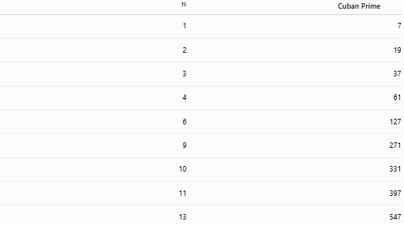
$$n$$ | Cuban Prime
1 | 7
2 | 19
3 | 37
4 | 61
6 | 127
9 | 271
10 | 331
11 | 397
13 | 547

